Digital Smart Door Lock Security System Using Arduino Uno Microcontroller
Suhana, Mehak Suri ,Garima
Department of Computer Science and Engineering, Lovely Professional University, Phagwara
suhanataneja145@gmail.com
garimaa298@gmail.com
mehaksuri36@gmail.com

Abstract- This research paper presents a microcontroller based digital door lock security system using keypad which will provide complete security solution to lives and properties at homes, schools and offices. The security system contains a 4X4 keypad input unit for entering the Personal Identification Number (PIN) and a display unit in form of Liquid Crystal Display (LCD) for visual display of information. In my door locking system, user interaction is facilitated through a keypad, where the entry of a correct password prompts the LCD display to showcase "Correct Door Opened." In case of an incorrect password input, the display responds with "Incorrect Password," accompanied by an audible buzzer alert for immediate user feedback.
Taking the security a step further, we've integrated a GSM module into the system. When an incorrect password is detected, not only does the buzzer sound, but the GSM module sends an SMS notification to the user's phone, providing real-time alerts on unauthorized access attempts.
To regulate the physical access, we've included a micro servo that governs the opening and closing of the door. This comprehensive integration of keypad, LCD display, buzzer, GSM module, and micro servo ensures a sophisticated and secure smart door locking system.
Keywords- microcontroller, 4X4 keypad input unit, LCD Display, GSM module.

INTRODUCTION
In the wake of a global security problem that manifests as an escalating rate of crime attacks on homes, offices, and various buildings, the imperative to enhance modern security systems becomes evident. The exponential growth in technology has ushered in both progress and challenges, demanding innovative solutions to safeguard lives and properties.
This research addresses this overarching security concern through the development of a Smart Door Lock System using Arduino microcontroller. Recognizing the need for comprehensive protection, our project integrates a buzzer and GSM module to amplify its security features. The strategically incorporated buzzer serves as a tangible advantage, providing audible alerts even in noisy environments, ensuring heightened awareness in case of security breaches.
Furthermore, the inclusion of a GSM module adds an extra layer of security. In situations where the audible alert may go unnoticed, the system sends an immediate message to the user's phone, notifying them of an incorrect password entry. This dual mechanism not only caters to varied environments but also ensures that users remain promptly informed, enhancing the overall effectiveness of the security system.
By undertaking this research and developing a technologically advanced Smart Door Lock System, we aim to contribute a practical solution to the widespread security challenges faced globally, bridging the gap between technological advancements and the imperative need for robust security measures in our homes, offices, and other crucial spaces.

LITERATURE SURVEY
In the literature survey, the choice of Arduino Uno for the smart door lock system is well-founded. Previous research has explored both Arduino microcontroller and Node MCU, but the decision to opt for Arduino Uno is supported by several key factors.
Arduino Uno’s widespread online content provides a significant advantage, facilitating project development with extensive support. Its robust voltage handling capability, up to 20 volts compared to Node MCU's 12 volts, contributes to enhanced reliability. Furthermore, the higher current-handling capacity of Arduino UNO, supporting 40 milliamperes per pin compared to Node MCU's 12 milliamperes, underscores its suitability for managing various components effectively.

It's crucial to acknowledge the challenges encountered during the implementation of the Smart Door Lock System using Arduino UNO. Despite its advantages, Arduino UNO does present certain limitations. The processor constraints of Arduino UNO were notable challenges, albeit manageable, requiring careful optimization of code and resource utilization.
Moreover, the cost factor emerges as another consideration. Arduino UNO is relatively costlier compared to Node MCU, which poses budgetary implications for large-scale implementations. Balancing the performance benefits of Arduino UNO with the associated costs becomes a critical aspect in decision-making.
In the ever-evolving landscape of smart door lock systems, a comprehensive review of existing literature reveals a multifaceted exploration of diverse approaches, with a discernible emphasis on the integration of Arduino microcontrollers. The extant body of research has diligently investigated various facets, ranging from system functionalities and security measures to the intricate challenges associated with seamless integration.
The prevailing discourse underscores the potential and versatility of Arduino-based systems, yet concurrently illuminates gaps and opportunities for refinement within this technological niche. User-friendliness, adaptability to diverse environments, and system robustness emerge as recurrent themes, prompting a critical examination of the existing frameworks.
Enter the focal point of this research—the Smart Door Lock System utilizing Arduino microcontroller. Positioned as an innovative response to identified gaps, this system not only capitalizes on the accessible ecosystem and extensive online support associated with Arduino UNO but introduces novel features that redefine the paradigm.
The strategic integration of a buzzer within the system adds a tangible layer of security, transcending the limitations posed by noisy environments. In doing so, the research not only acknowledges real-world challenges but proposes a practical solution, augmenting the system's efficacy in scenarios where auditory cues are crucial.
Further fortifying its standing, the introduction of a GSM module elevates the system to a new echelon of security. This dual-layered approach, combining audible alerts with immediate user notifications, addresses the nuanced concerns of oversight and user awareness in the event of unauthorized access attempts.
As this research unfolds, the narrative pivots towards pivotal questions. How does this innovative system perform under varied conditions? What transformative impact do the integrated buzzer and GSM module have on the overall security landscape? These questions guide the trajectory of inquiry, setting the stage for an in-depth exploration and contribution of the Smart Door Lock System using Arduino microcontroller to the evolving tapestry of smart security solutions.

• System Block Diagram

The flow chart below depicts all the components that we have used in our research, it contains an Arduino Uno microcontroller, a buzzer, a micro servo, an LCD Display, a GSM module, and a 4X4 keypad.

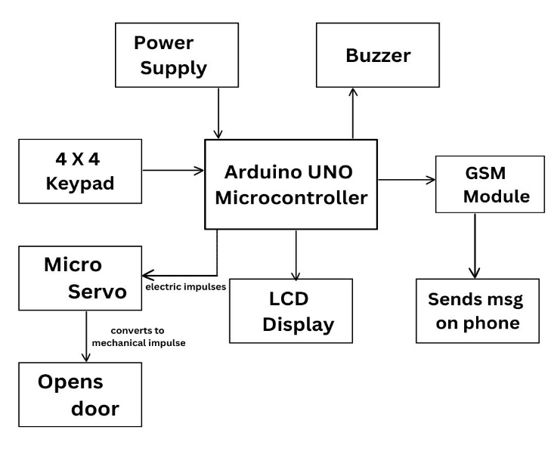 Block Diagram
Table: Hardware Components Description
Item | Mode | Description
Power Supply | Input | Supplies 5V to Arduino Microcontroller which powers  all other models
4X4 Keypad | Input | It helps in inputting PIN in the system
Buzzer | Output | Makes audible sound in event of wrong PIN
GSM Module  Micro Servo | Output  Output | Signals the user via messages that whether the pin entered is correct or not  Regulates opening and closing of the door, basically it converts electronic signals from the system into precise mechanical movements
LCD display | Output | Displays the state of the system and  PIN entered.
.
Flow Chart
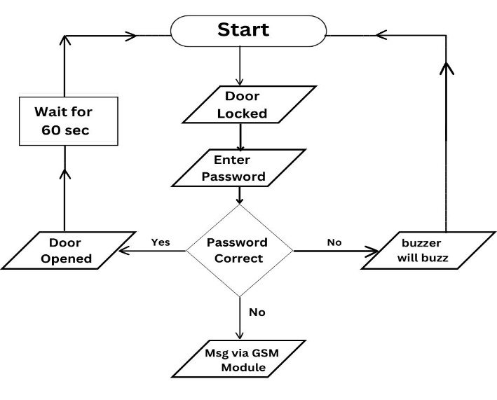
Procedure
- System starts in the locked state.
- User enters password via numpad.
- If correct password:
  - Display "Correct Password" on LCD.
  - Open the door.
- If incorrect password:
  - Display "Incorrect Password" on LCD.
  - Buzz the buzzer.
  - Send GSM message: "Incorrect Password Entered" to specified phone number.
- System returns to locked state after incorrect attempt.
- End.

RESULT

In the results of our Smart Door Lock System, we observed a high success rate in password entry and verification, showcasing the reliability of the keypad module. The system demonstrated swift responsiveness to correct password entries, with the microcontroller efficiently triggering the micro servo to open the door. The GSM module effectively sent timely notifications to users' phones in case of incorrect password attempts, enhancing security alerts. The LCD display provided accurate and clear feedback on the entered password's accuracy, contributing to a user-friendly interface. Additionally, the buzzer performed well in alerting users to incorrect password entries, adding an audible layer to security measures. Overall, the system exhibited commendable performance, fulfilling the envisioned objectives of providing secure and
responsive door access control. 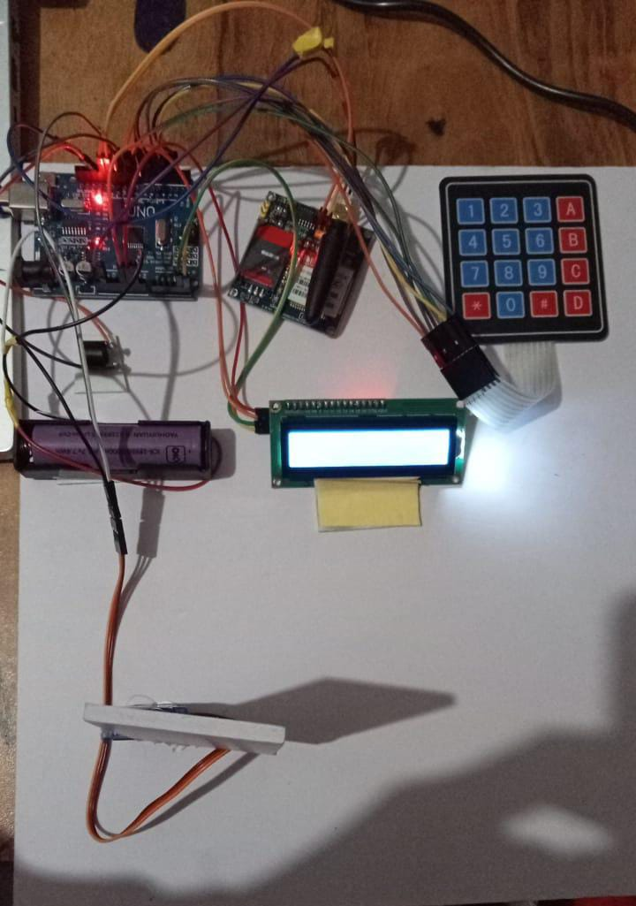

Components |  | Function | Our smart door lock system | Other research papers
Arduino Uno |  | Microcontroller for system orchestration | YES | Possible YES
LCD Display |  | Visual representation of system status | YES | Possible YES
GSM Module |  | Messaging and alert notifications | YES | Possible YES
Keypad |  | User input for password entry | YES | Possible YES
Buzzer |  | Audible alert for incorrect passwords | YES | Possible NO
Micro Servo |  | Converts electronic impulses to mechanical movement for door control | YES | Possible YES
 | Bluetooth Module | Used in short distance wireless communication | NO | Possible Yes
 | Node MCU | Helps to prototype or built IoT products | NO | Possible YES

METHADOLOGY
The proposed methodology for our Smart Door Lock System is an intricate dance of three pivotal modules. At its heart lies the microcontroller module, featuring the versatile Arduino UNO. This orchestrator interfaces seamlessly with the keypad module, a 4x4 matrix capturing user-entered passwords crucial for door access.
The keypad, serving as the gateway for password input, provides a secure means of interaction. A crucial enhancement is the integration of a GSM module, which acts as a vigilant guardian. In the event of an incorrect password, this module swiftly dispatches a message to the user's phone, serving as an immediate alert mechanism.
Adding a visual dimension to the user experience, an LCD display mirrors the system's outcome, indicating whether the entered password aligns with the system's expectations. Successfully navigating this digital passcode initiates a symphony of actions – Arduino signals a micro servo, which deftly translates electronic impulses into the mechanical movement required to open the door.
Conversely, an incorrect password triggers a coordinated response. The buzzer resonates, alerting anyone in the vicinity, while a message detailing the security breach is transmitted via GSM.
This holistic integration of modules forms the backbone of our methodology, promising not just security but a responsive and user-friendly Smart Door Lock System.
FUTURE SCOPE
The future scope of the Smart Door Lock System using Arduino microcontroller is promising and opens avenues for continued innovation. Considerations for biometric integration, incorporating fingerprint or facial recognition, can elevate security measures. Extending the system's functionality to integrate with broader smart home systems would enable users to control and monitor door access remotely. Exploring machine learning algorithms for advanced pattern recognition and anomaly detection could make the system more intelligent. Investigating enhanced communication protocols, energy-efficient features, and cloud integration can contribute to a more seamless and sustainable user experience. Additionally, refining user access management, implementing robust cybersecurity measures, and offering customization options present exciting directions for the evolution of this smart security solution. Expanding market accessibility through mass production further contributes to the future scalability and relevance of the Smart Door Lock System.

CONCLUSION

The microcontroller based digital door lock security system using keypad is effective in providing security to lives and properties as long as the PIN is not shared with unauthorized person. The system is cheap, affordable, small and relatively easy enough to install with just a couple of steps. Our smart door locking system seamlessly integrates cutting-edge technologies such as a keypad, LCD display, micro servo, and GSM module. This cohesive fusion results in an advanced security solution that not only ensures controlled access through password verification but also provides real-time alerts via SMS in the event of unauthorized attempts. The incorporation of a micro servo adds a physical layer to the security by regulating the door's movements. Through careful integration and functionality, our project not only enhances convenience but also prioritizes user awareness and safety in securing access to the designated space.

REFERENCES
- https://www.researchgate.net/publication/369296204
- Ashish Chittora (2012), "4x4 MATRIX KEYPAD" Retrieved: November 20, 2018 Available at: http://eforengineers.blogspot.com/2012/10/4x4- matrix- keypad.html
- Price It Here, (2015), "Door Access Control Systems – Cost Introduction" Retrieved: November 15, 2018, Available at: https://priceithere.com/access-control-system-cost/
- https://chat.openai.com/c/670265b6-7060-4f81-96d3-3bddf1b961c9
- The Workplace Depot, (2013), "Advantages and Disadvantages of Digital Door Locks" Retrieved: December 21, 2018, Available at: https://www.theworkplacedepot.co.uk/news/201 3/03/11/advantage s-and-disadvantages-ofdigital-door-locks/

